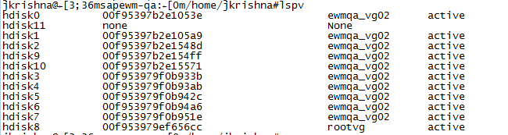
cd /tmp/
gunzip -c AIX71_TL5SP1.tar.gz | tar xvf –
cd AIX71_TL5SP1
smitty alt_clone
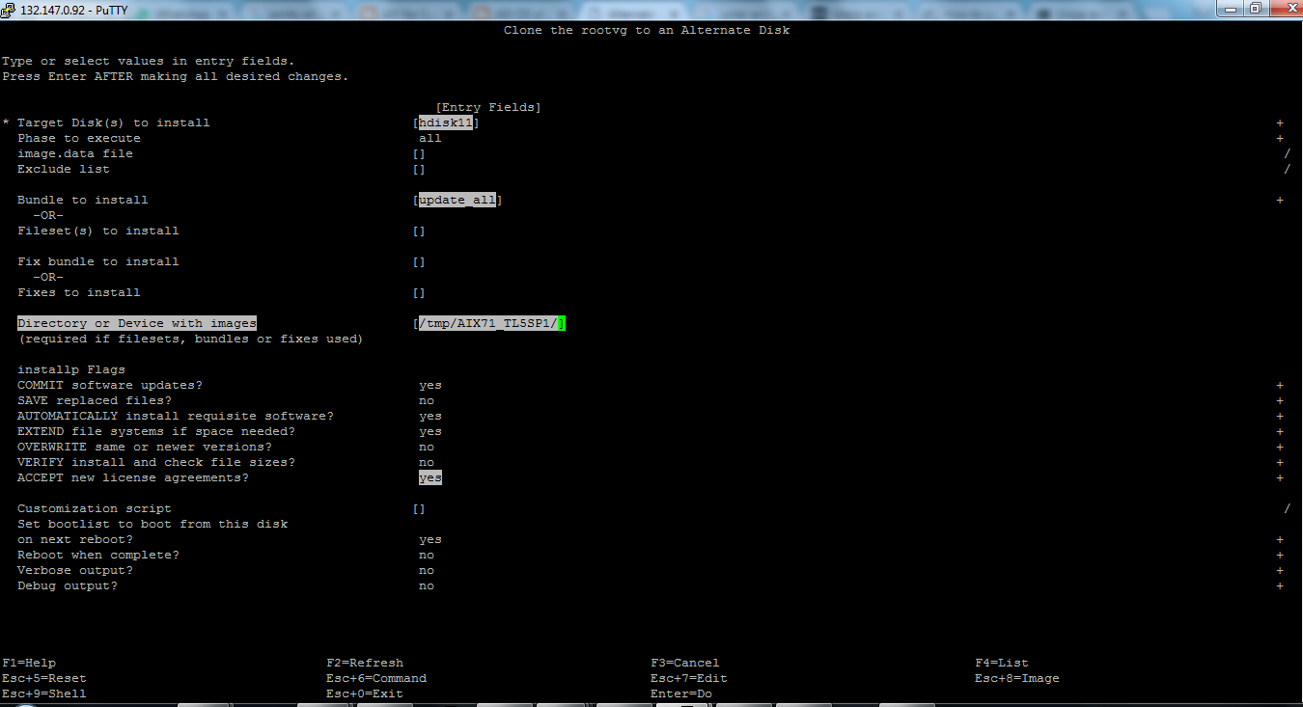

alt_disk_install -W hdisk11
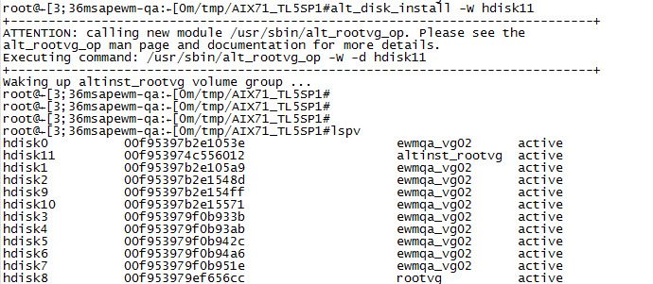
chroot /alt_inst /usr/bin/oslevel –s
alt_disk_install -S hdisk11
